Tomcat Deployment

1.pre-requisite: Ec2-instance with java

Installation

Imp: Do it as a admin

1. Download tomcat packages from <https://tomcat.apache.org/download-80.cgi>

. wget http://mirrors.fibergrid.in/apache/tomcat/tomcat-8/v8.5.35/bin/apache-tomcat-8.5.35.tar.gz

. tar -xvzf /opt/apache-tomcat-8.5.35.tar.gz

2.go to bin and restart tomcat service

./shutdown.sh

./startup.sh

3. access tomcat application from browser on port 8080

* http://<Public_IP>:8080

4. To access tomcat server from all.

find / -name context.xml

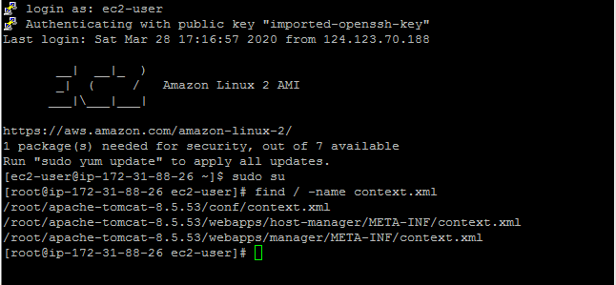



5.vi tomcatcatuser.xml and add roles and usernames and passwords to manage gui and to push file from Jenkins to tomcat server

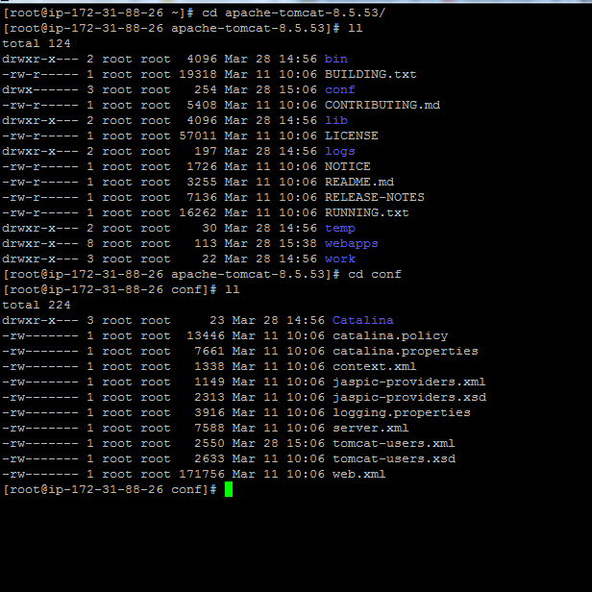

To interact gui we will create manager-gui role ,user and password.

To push file from server to tomcat we use script

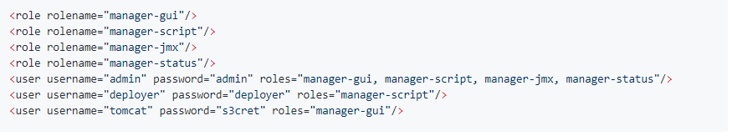

Open <ip>:8080

Goto Jenkins

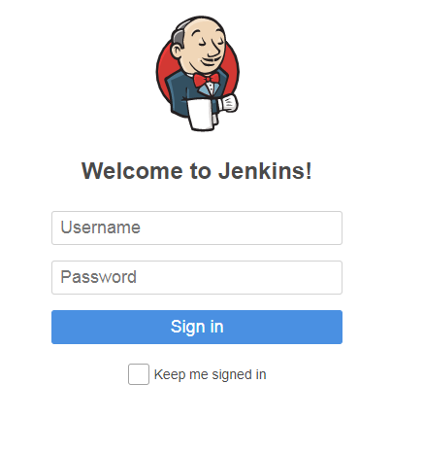

Go to 🡪Mange Jenkins🡪manage plugins🡪search deploy to container plugin in available🡪insatall without restart



Go to 🡪credentials 🡪global🡪add credentials🡪enter tomcat cat credential to push code to tomcat from Jenkins server

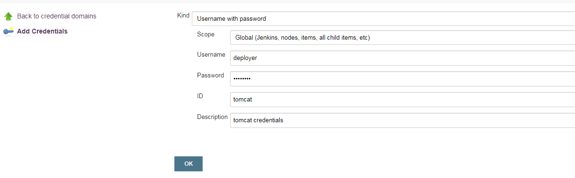

Create job for tomcat deployment

Newjob🡪tomcat freestyle job

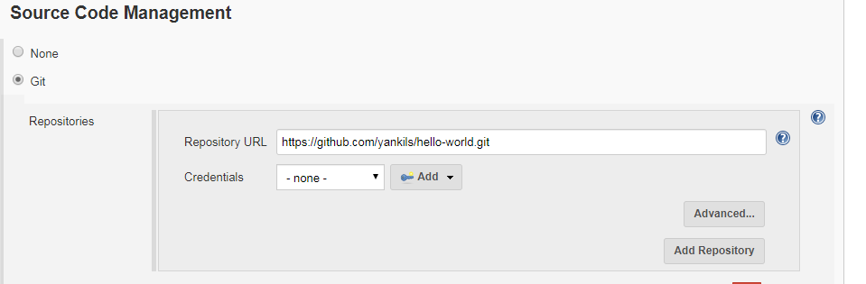

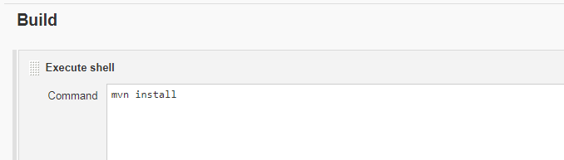

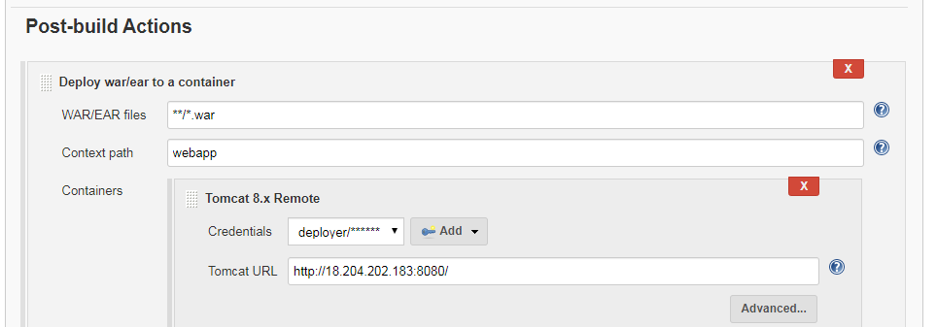

Build job and after successfull completion goto <ip>:8080/webapp